Бегущий счёт
tmax=2;
n=100;
m=100;
h=(-1)/(n-1);
tau=tmax/(m-1);

eps=0.000001;
Y=zeros(n,m);
% Зададим НУ и граничные условия:
Y(1,1)=0;
for i=2:n Y(i,1)=sin((pi/2)*((i-1)*h)); end
for j=2:m Y(1,j)=0; end

for j=1:(m-1)
for i=1:(n-1)
f=(Y(i,j+1)-Y(i,j)+Y(i+1,j+1)-Y(i+1,j))/(2*tau)-(exp(-(Y(i+1,j))^2)- exp(-(Y(i,j))^2)+ exp(-(Y(i+1,j+1))^2)- exp(-(Y(i,j+1))^2))/(2*h);

df=1/(2*tau)+ 2*(Y(i+1,j+1))*exp(-(Y(i+1,j+1))^2)/h;
Y(i+1,j+1)=Y(i+1,j+1)-f/df;
while abs(f/df)>eps
f=(Y(i,j+1)-Y(i,j)+Y(i+1,j+1)-Y(i+1,j))/(2*tau)-(exp(-(Y(i+1,j))^2)- exp(-(Y(i,j))^2)+ exp(-(Y(i+1,j+1))^2)- exp(-(Y(i,j+1))^2))/(2*h);

df=1/(2*tau)+ 2*(Y(i+1,j+1))*exp(-(Y(i+1,j+1))^2)/h;

Y(i+1,j+1)=Y(i+1,j+1)-f/df;
end
end
end
i=1:n;
X(i)=(i-1)*h;
j=1:m;
T(j)=(j-1)*tau;

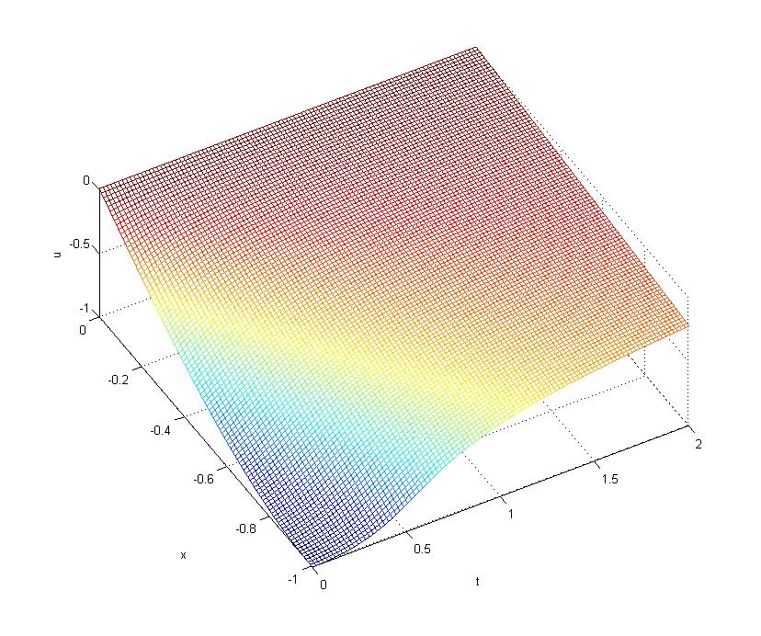
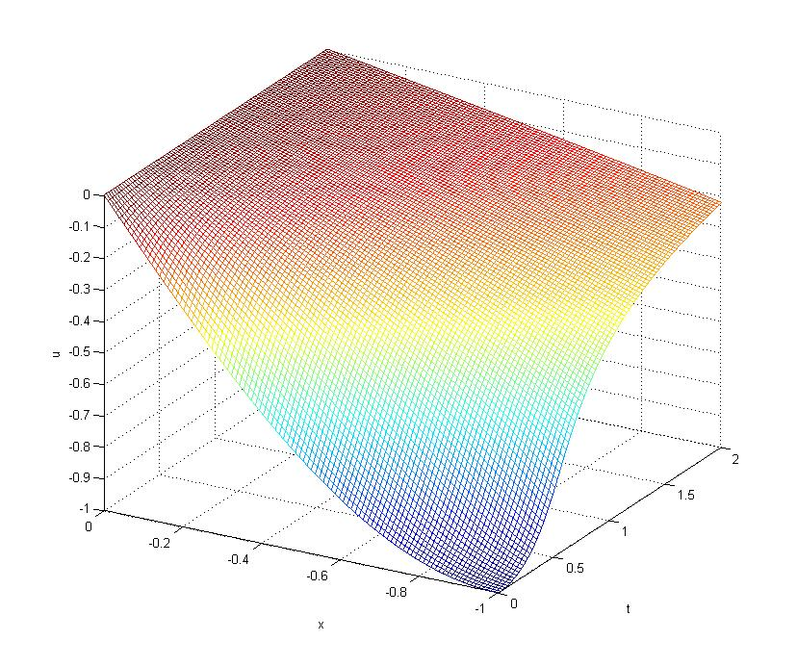
mesh(T,X,Y)

Прогонка
x=0:0.01:1;
h=0.01;
t=0:0.001:0.1;
Tau=0.001;

U=zeros(101,101);
U(1,:)=0;
U(:,2)=U(:,1);
U(:,101)=U(:,100);
% Зададим коэффициенты для аппроксимации уравнения:
A=1/(2*h^2);
C=1/Tau + 1/h^2;
for k=1:1:100
%Прогонка, прямой ход
Alfa=zeros(101);
Beta=zeros(101);
for i=2:1:100
F(i)=U(k,i)*(1/Tau-1/h^2) + A*(U(k,i-1)+U(k,i+1))+i*h*(k*Tau)^2;
Alfa(i+1)=A./(C-A.*Alfa(i));
Beta(i+1)=(A.*Beta(i)+F(i))./(C-A.*Alfa(i));
end;
%Прогонка, обратный ход
for n=100:-1:2 U(k+1,n)=Alfa(n+1).*U(k+1,n+1)+Beta(n+1); end;
end;
[X,T] = meshgrid(x,t);
Z=U;
mesh(X,T,Z);

